**Lessons 1 & 2**

**Term Search**

**Name: Farid Hasanov**

1) What is Data?

Data is recorded information, the representation of facts, concepts or procedures in a form suitable for communication, combination, processing by human or automatic means.

2) Please share some examples of apps/games/tools that track and use your data:

Pay Pal, QIWI, Yandex Money, Origin, Steam, Google, Epic Games. All of those and millions another apps that always asking you to input your data and contains that.

3) What is the job of a Network

Network Engineers are responsible for designing, implementing, monitoring and managing the local and wide area networks of an organization to ensure maximum uptime for users.

4) What is the main difference between a LAN and WAN

A LAN, abbreviated from Local Area Network, is a network that covers a small geographical area such as homes, offices, and groups of buildings. Whereas a WAN, abbreviated from Wide Area Network, is a network that covers larger geographical areas that can span the globe.  
  
From pptx: A wide are network (WAN) is a network that exist over a large-scale geographical are. A WAN connects different smaller networks, including local are networks (LANs). This ensures that computers and users in one location can communicate with computers and users in one location can communicate with computers and users in other location.  
  
An enterprise network is an enterprise’s communications backbone that helps connect computers and related devices across departments and workgroup networks, facilitating insight and data accessibility.  
  
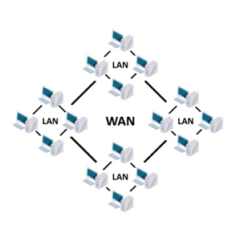

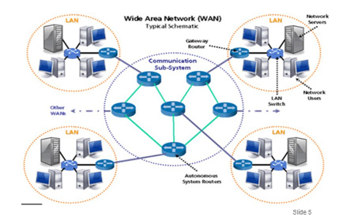

5) Please share an example of a real-world LAN and a WAN

The Internet is a WAN. A network of bank cash dispensers is a WAN. A school network is usually a LAN. LANs are often connected to WANs, for example a school network could be connected to the Internet.

6) What is the main purpose of a Server?

To store and manage the databases of the client / server system, each server requires a Database management system (DBMS) like Microsoft SQL server.

7) What is the main purpose of a Client?

Application software

Data access API (application programming interface)

The client software does the front-end processing.

8) Name the Database (DB) Server we are using in this class:

SQL Server

9) Name the DB Client we are using in this class:

Microsoft SQL Server Management Studio 18

10) What does SQL stand for?

SQL stands for Structured Query Language. SQL is used to communicate with the database.

Is SQL Case-Sensitive? No Can Case be used for easier reading? Yes

11) What are tables?   
  
A table is a collection of related data held in a table format within a database. It consists of columns, and rows. For example, a table of cars might list the makes, models, year, Mileage, # of doors, and price of each car.

12) What are fields/columns/cells?   
  
A column/field is a set of a data values, all of a single type to represent a particular property of an object, person, action.

13) What are records/rows?   
  
A row/record represents a single, implicitly structured data item in a table.

14) How are tables, fields, and rows related to each other? Is there an Google/Office application that sounds like it has these things? Or maybe something similar from school or a game you played as a kid?

Game Tic Tac Toe.   
  


15) What is a Primary Key and its purpose? Can you give an example from real life that act like primary keys?  
  
A Primary Key is a field in a table which uniquely identifies each row/record in a database table. Primary keys must contain unique values. A primary key column cannot have NULL values. A table ca have only one primary key, which may consist of a single or multiple fields. For example a table of cars use a VIN # as a unique identifier.

16) What is a Relational Database? What does the word “Relational” mean to you in your life? Explain how it can be transferred/connected to Relational Databases?  
  
A relational database is a collection of data items with pre-defined relationships between them. These items are organized as a set of tables with columns and rows. Tables are used to hold information about the objects to be represented in the database. Each column in a table holds a certain kind of data and a field stores the actual value of an attribute. The rows in the table represent a collection of related values of one object or entity. Each row in a table could be marked with a unique identifier called a primary key, and rows among multiple tables can be made related using foreign keys. This data can be accessed in many different ways without reorganizing the database tables themselves.

17) What are Foreign Keys and how are they related to Primary Keys  
  
A Foreign Key is a column or group of columns in a relational database table that provides a link between data in two tables. These are usually primary keys from another table.

18) What type of field data type would you use for the following? (Hint: Slide 22 has Data Types)  
  
Number of Tires on a Car: Int

Hourly Pay Rate: Float

Birthdate: DateTime

First Name: NVarChar()

Last Name: NVarChar()

True or False: Bit

Date & Time of Purchase on a receipt:   
  
DateTime

Zip Code (Hint this one is tricky) :

NVarChar()

Area Code (Tricky): NVarChar()

7-digit Phone # (Tricky): NVarChar()

19) Please fill the field with a null value:

20) Name the four core SQL commands for data manipulation:   
SELECT – to query data in the database

INSERT – to insert data into a table

UPDATE – to update data in a table

DELETE – to delete data from a table